School of Computing, Creative Technologies, and Engineering 2021/22
Level 6 Production Project
MEETING RECORD SHEET: |  |  | Meeting  Number: 4
Student: Anupam Siwakoti |  | Student I.D.: C7227267
Date of Meeting: March 12th, 2022 |  | Supervisor: Resham Bdr Pun
Actions agreed at previous meeting (completed or comment):
1 | Completed the implementation of layered architecture with DDD ¨
2 | Started to learn about hexagonal architecture ¨
3 | Reviewing architecture of different software’s ¨
4 | ¨
5 | ¨
6 | ¨
Comments of student (if any):
This was the fourth meeting with our supervisor, he reviewed the implementation of the layered architecture. He was positive on the progress

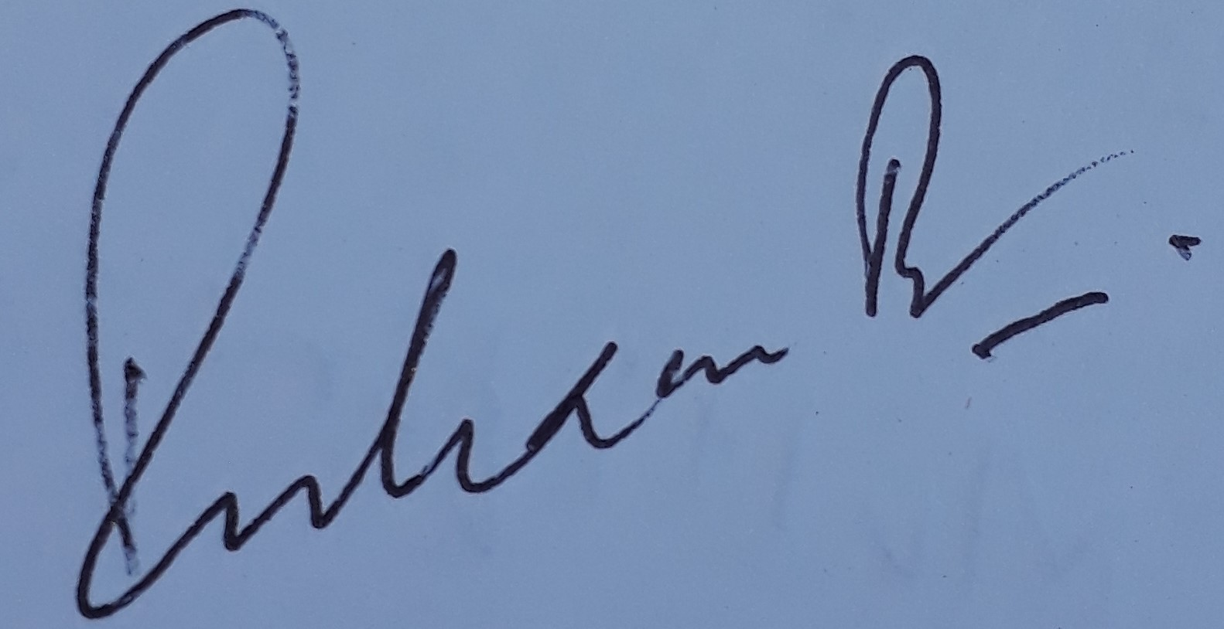
ABOVE here – student to complete before Meeting with supervisor. BELOW here – complete at the Meeting.
Next meeting (date/time): March 21st, 2022
Agreed Actions to complete before next meeting:
1 | Learn on about hexagonal architecture
2 | Write down all the step-up procedure for the project setup
3 | Learn about the message broker for pub-sub
4
5
6
Comments of supervisor (if any):
No comments, I saw his layered architecture, he is on progress.

